LAKSHY JAIN

|  |  |  |
| --- | --- | --- |
| **Assignment** | **:** |  |
| **Module -1: Understanding of Hardware and Its**  **Components** | | |

a

**Section 1: Multiple Choice**

1. Which of the following is NOT a component of the CPU?
   1. ALU
   2. RAM
   3. CU
   4. 1 and 3 both

Ans: ram

Note:-because ram is a storage component.

1. What is the function of RAM in a computer?

Ans: RAM, or random access memory, is a computer's short-term memory that stores data and programs that are currently in use. RAM's main function is to store data that the computer's processor needs to access quickly.

1. Which of the following is a primary storage device?
   1. HDD
   2. SSD
   3. SD card
   4. 1 and 2 both

Ans :1and 2 both

Note HDD and SSD both are primary storage device

1. What is the purpose of a GPU?

ANS:A graphics processing unit (GPU) is a hardware component that helps process graphics-related tasks like rendering images, videos, and animations. GPUs are also known as graphics cards or video cards.

**Section 2: True or False**

1. True or False: The motherboard is the main circuit board of a computer where other components are attached.

Ans true

1. True or False: A UPS (Uninterruptible Power Supply) is a hardware device that provides emergency power to a load when the input power source fails.

Ans true

1. True or False: An expansion card is a circuit board that enhances functionality of a component.

Ans true

**Section 3: Short Answer**

1. Explain the difference between HDD and SSD

Ans HDD SSD

. slower . faster

.cheaper . more expensive

.machanical(moving parts) .non mechanical(flas

.fragile .shock-resistant

. best for storing extra data .best for storing opreting system,

Such for movies,photos, gaming apps and frequently

And documents. used files.

1. Describe the function of BIOS in a computer system.

Ans: BIOS, or Basic Input/Output System, is a computer program that controls a computer's basic hardware functions and starts up the computer when it's turned on BIOS is pre-installed on the computer's motherboard and is typically stored in an EPROM chip. To enter the BIOS setup, you need to press a specific key, such as F1, F2, F10, DEL, or ESC, as soon as the manufacturer's logo appears but before the operating system loads.

10.List and briefly explain three input devices commonly used with computer. Ans :In computing, an input device is a piece of equipment used to provide data and control signals to an information processing system, such as a computer or information appliance. Examples of input devices include keyboards, computer mice, scanners, cameras, joysticks, and microphones.

**Section 4: Practical Application**

11.Identify and label the following components on a diagram motherboard

CPU

RAM

SATA connectors



RAM PCI-E slot SATA connectors



CPU



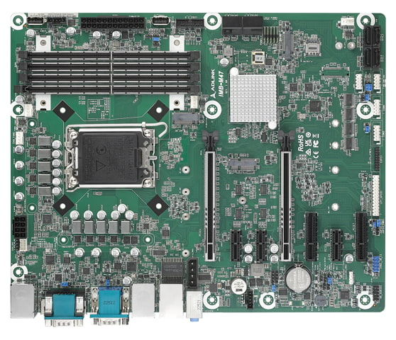

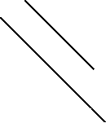

PCI-E SLOT



1. Demonstrate how to install a RAM module into a computer.

Ans: Here are some steps to install a RAM module into a computer:

Turn off and disconnect: Turn off the computer and unplug all power cables.

Open the case: Open the computer's case to access the motherboard. You may need a Phillips screwdriver and your owner's manual.

Ground yourself: Touch an unpainted metal surface to prevent static discharge from damaging the computer's components.

Find the RAM slots: The RAM slots are usually located near the central processing unit (CPU).

Remove existing RAM: If there are existing RAM modules, release the clips on either side and gently pull them out.

Install new RAM: Align the notches on the RAM module with the ridges in the slot. Then, firmly press the RAM into the slot until the clips snap into place.

Reassemble: Reassemble the computer's case and plug all cords and accessories back in.

**Section 5: Essay**

13.Discuss the importance of proper cooling mechanisms in a computer system. Include examples of cooling methods and their effectiveness.

Ans: Proper cooling is important for computer systems because it keeps components within safe operating temperatures and prevents overheating, which can lead to performance issues, reduced service life, and electronic failures:

Overheating components: Overheating can cause components like the CPU, graphics card, hard disk drive, and solid state drive to malfunction or fail permanently.

Performance issues: Overheating can cause performance issues.

Reduced service life: Excessive heat can reduce the service life of electronic equipment.

Electronic failures: Excessive heat can lead to electronic system failures.

Here are some examples of cooling methods and their effectiveness:

Air cooling

The most common method, air cooling uses fans to move air over the CPU's heat sink to dissipate heat.

Liquid cooling

Liquid cooling systems use a liquid to transfer heat away from the processor, which is then cooled by air. Liquid cooling is more efficient than air cooling and can be used for higher performance computing devices.

Direct-to-chip cooling

This method optimizes the interface between the liquid system cold plate and the chip package to enhance heat transfer efficiency and allow precise temperature control.

14.Explain the concept of bus width and its significance in computer architecture.

Ans: Within each data transfer there can be multiple bits of data. This is described as the width of a bus which is the number of bits the bus can transfer per clock cycle and can be synonymous with the number of physical electrical conductors the bus has if each conductor transfers one bit at a time.